ITMAL

Hand-in: Journal 2

Af Gruppe 12

Indhold

Gradient descent 3

Qa: 3

Qb: 4

Qd: 5

Forklaring: 5

Qe: 5

Capacity under overfitting 6

Qa: 6

Qb: 6

Generalization error 7

Qa: 7

Qb: 7

Qb part II: 8

Naïve Bayes 8

Regulizers 9

Qa: 9

Qb: 10

Qc: 12

Qd: 12

Gridsearch 12

Qa 12

Cell 1 13

Cell 2 13

Qb 14

Qc 15

Qd 17

Speed up by compression 19

Noise reduction 19

PCA -> t-SNE features 20

Neurons 20

Qa: 20

Qb: 20

Perceptron 21

Qa: 21

Qb: 21

Qc: 22

Qd: 22

Multi-layers Perceptrons (MLP) 23

Qa: 23

Cell 1 23

Cell 2 23

Cell 3 24

Qb: 25

Qc: 25

Keras Multi-Layer Perceptrons (MLP’s) on MNIST-data 27

Qa: 28

Qb: 30

# Gradient descent

## Qa:

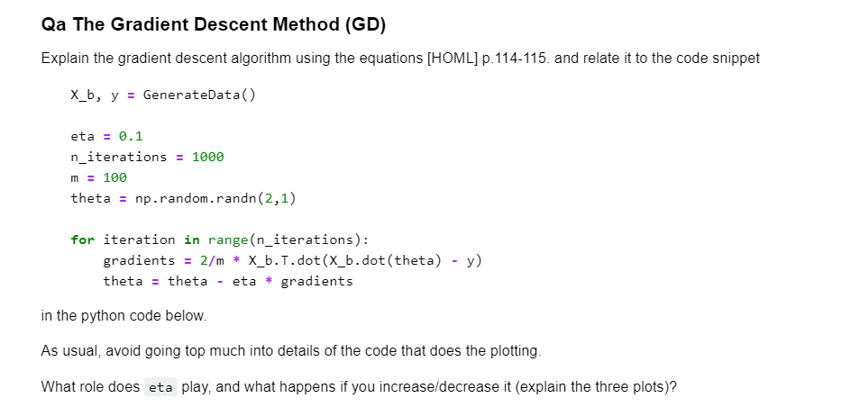

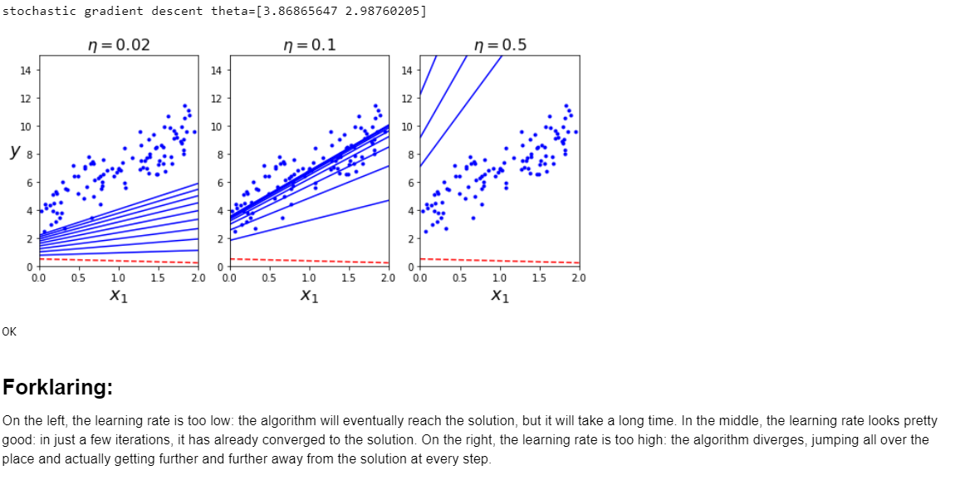

## Qb:

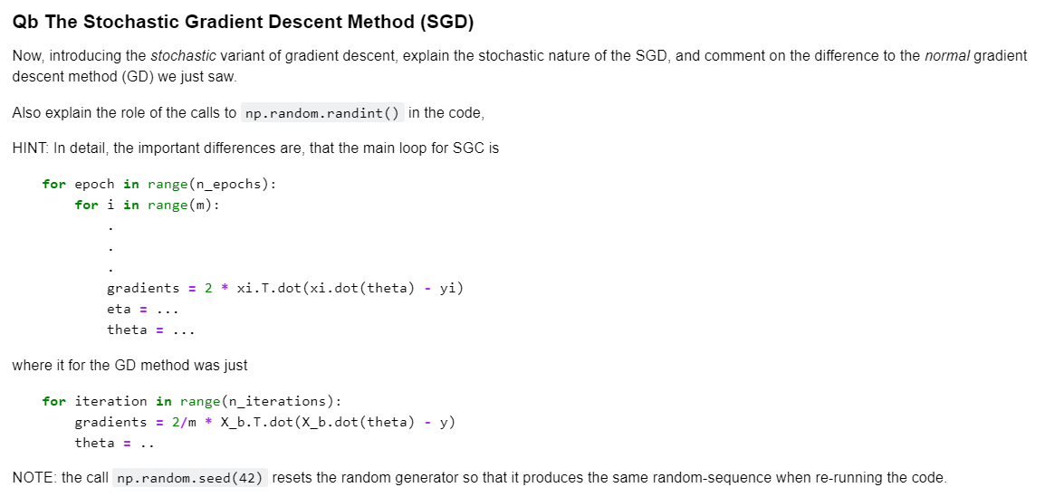

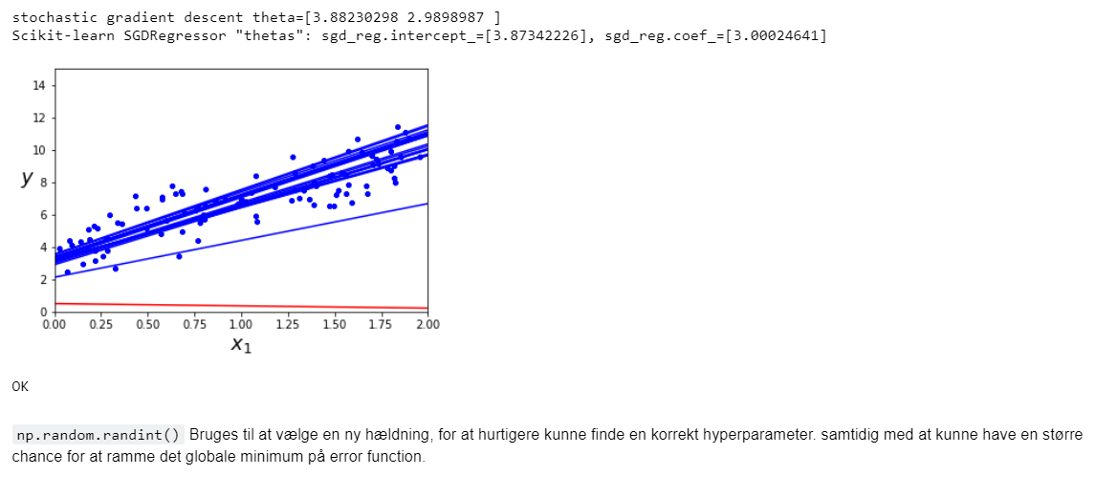

## Qd:

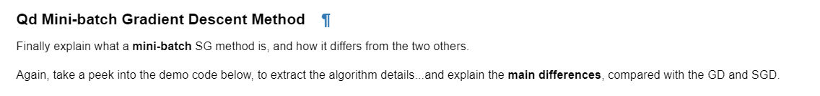

### Forklaring:

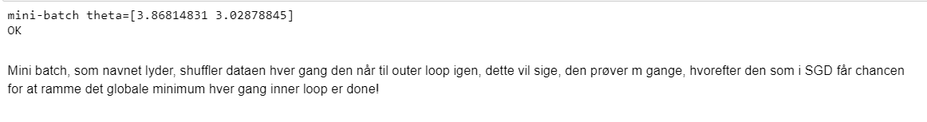

## Qe:



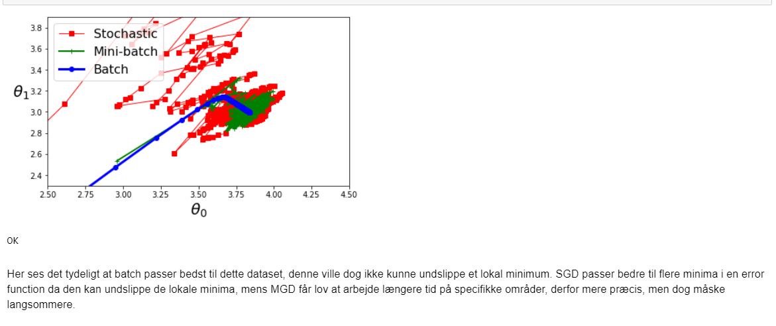

# Capacity under overfitting

## Qa:

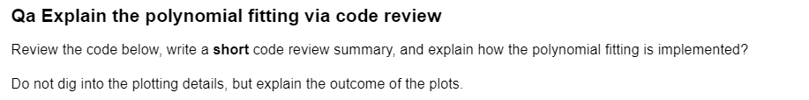

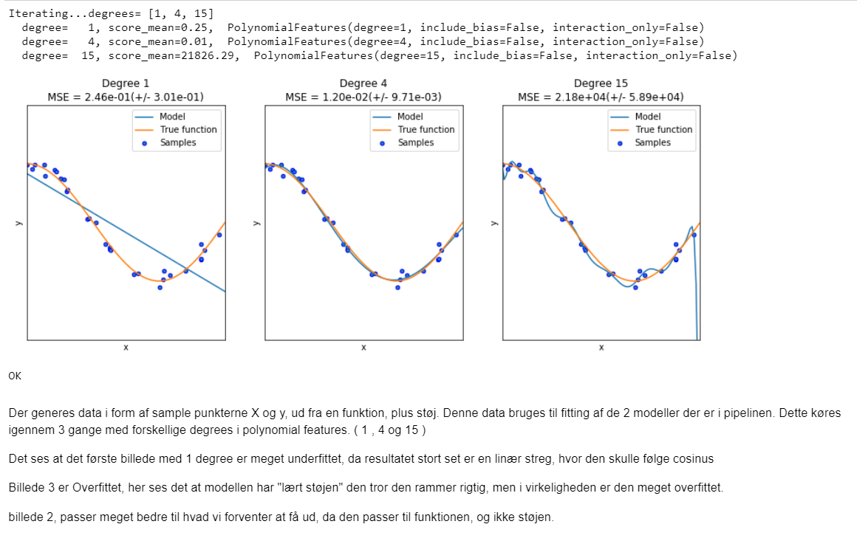

## Qb:

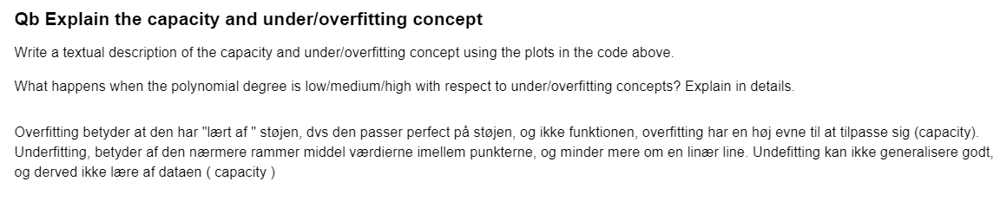

# Generalization error

## Qa:

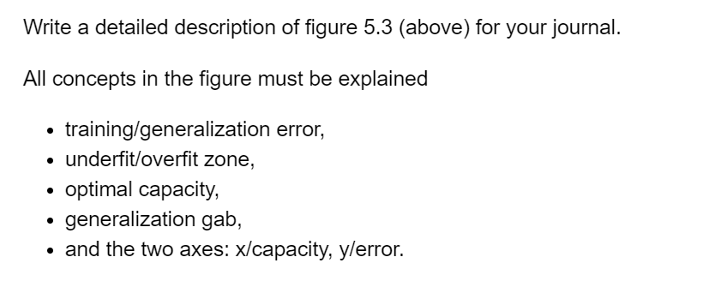

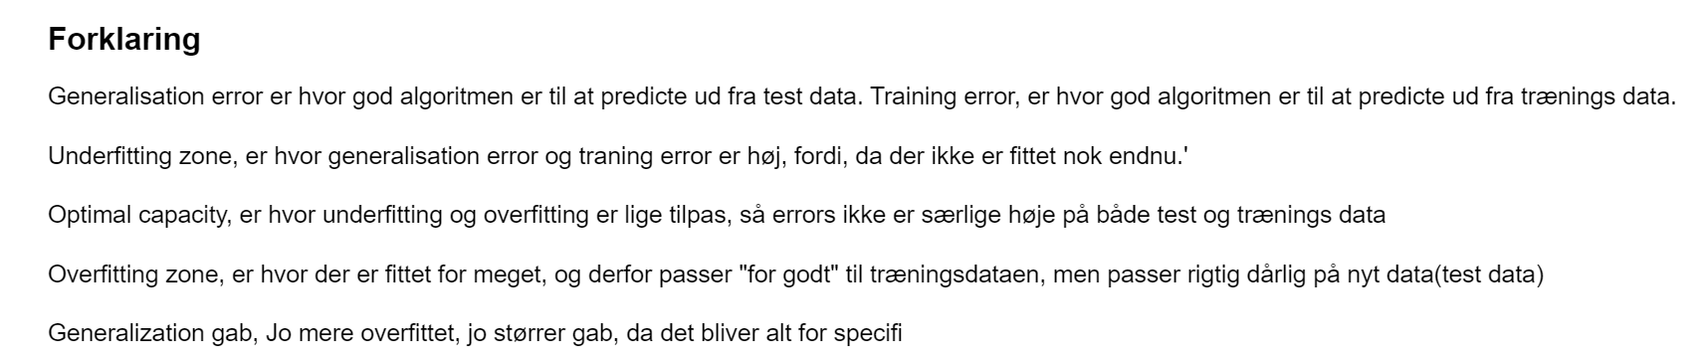

## Qb:

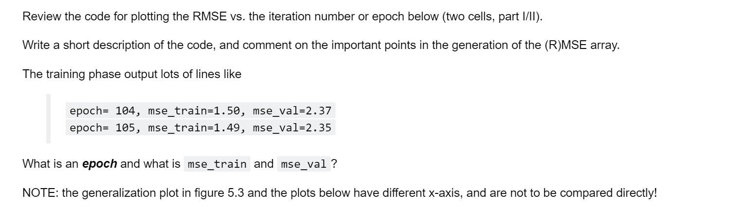

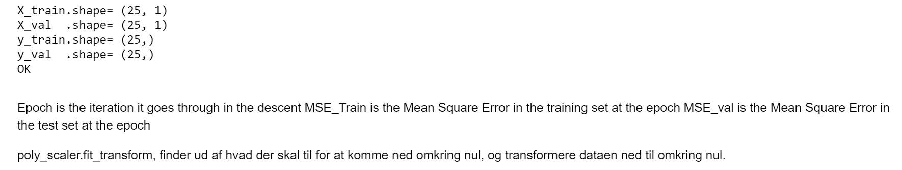

## Qb part II:

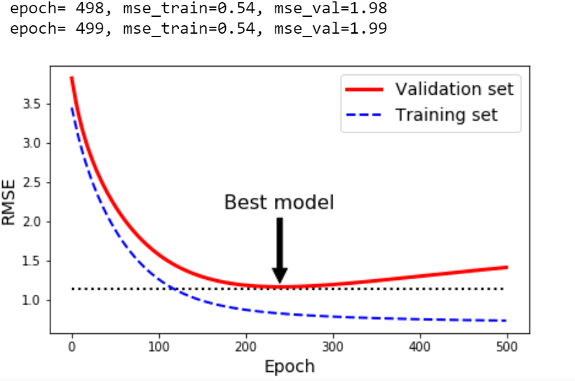

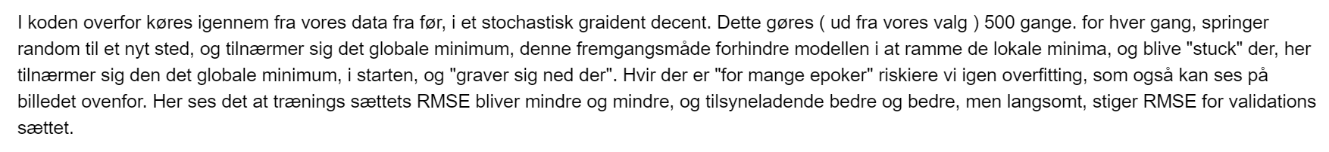

# Naïve Bayes

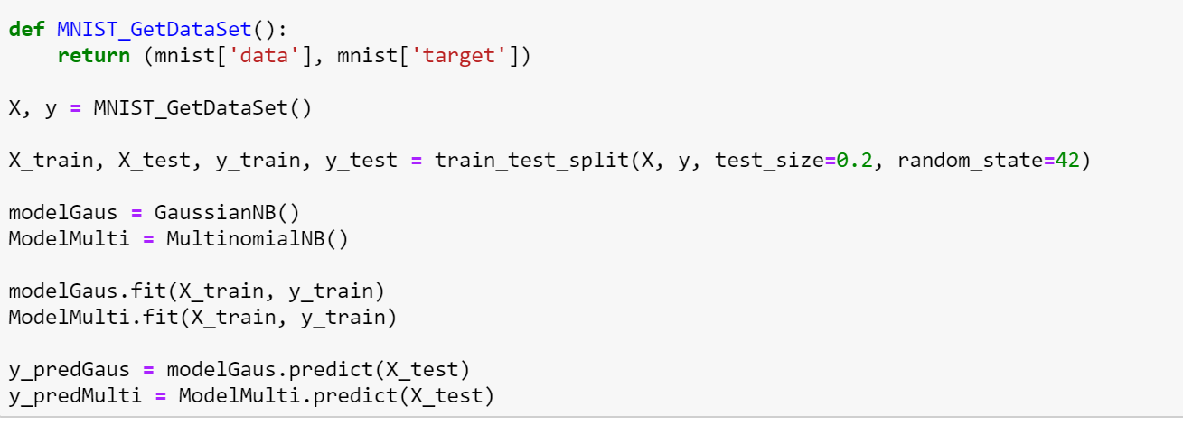

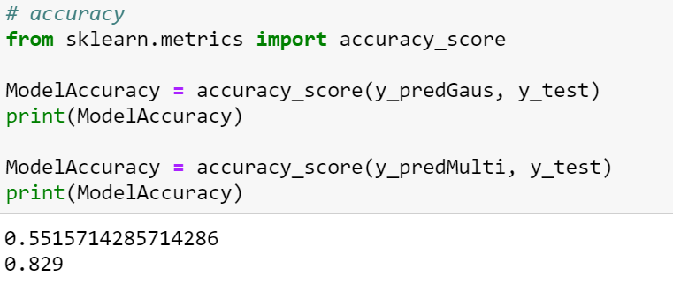

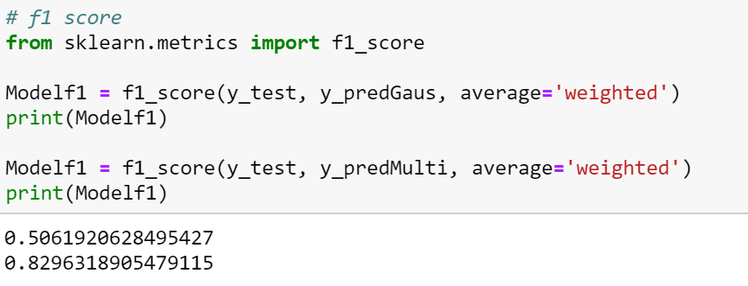

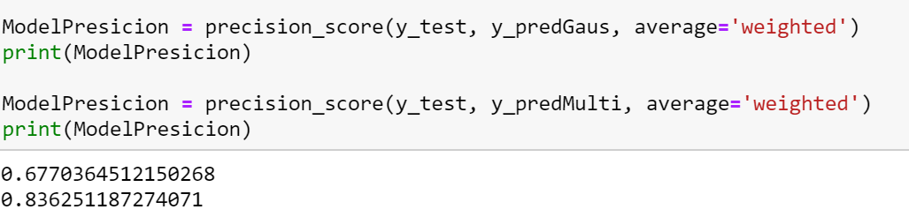

# Regulizers

## Qa:

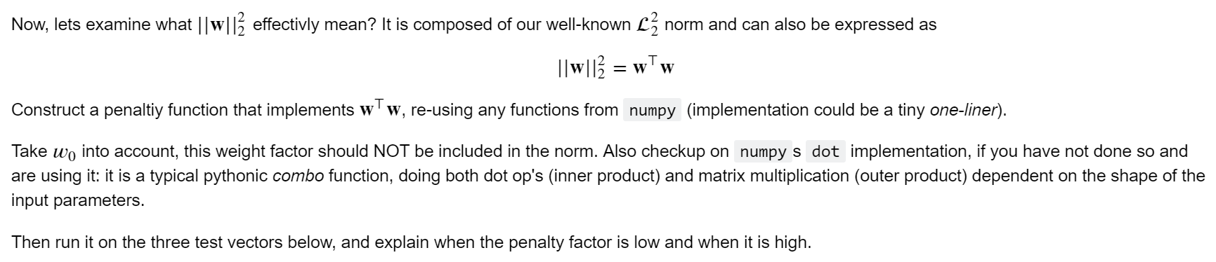

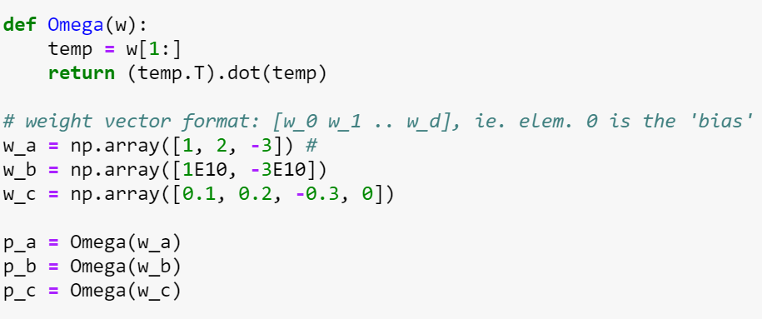

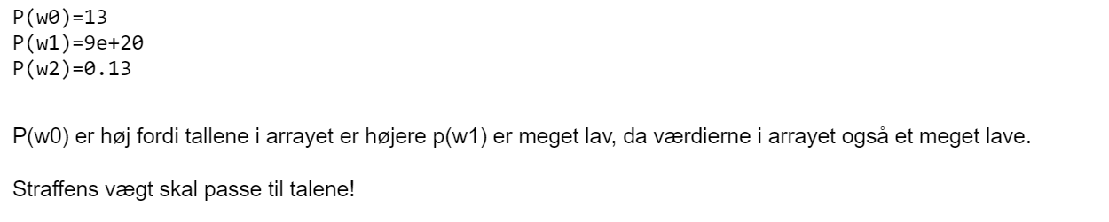

## Qb:



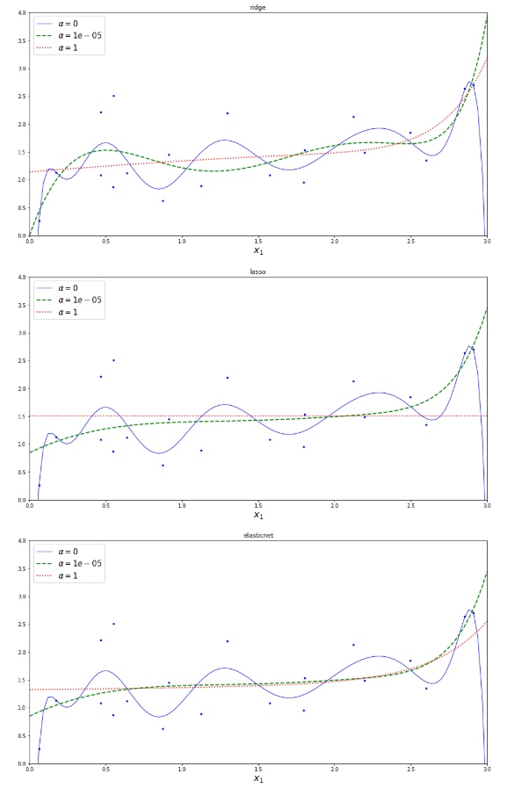

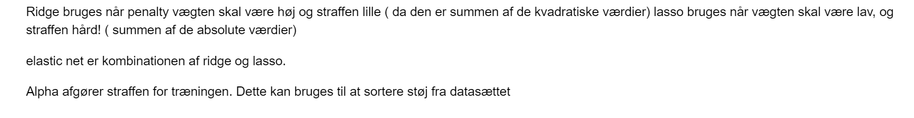

## Qc:

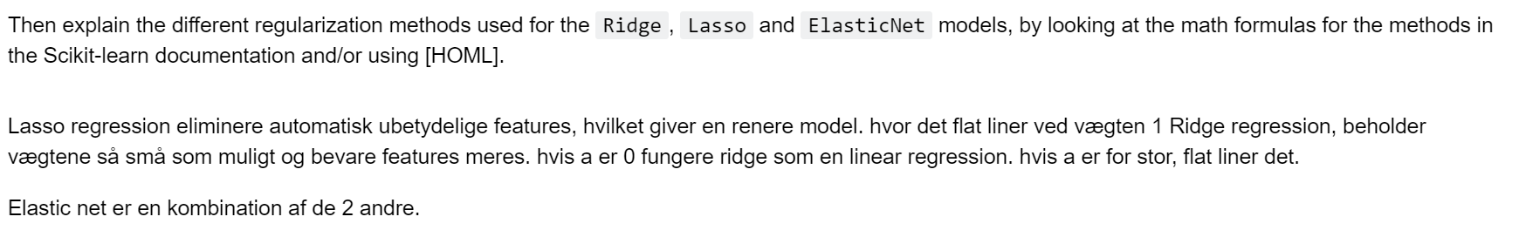

## Qd:

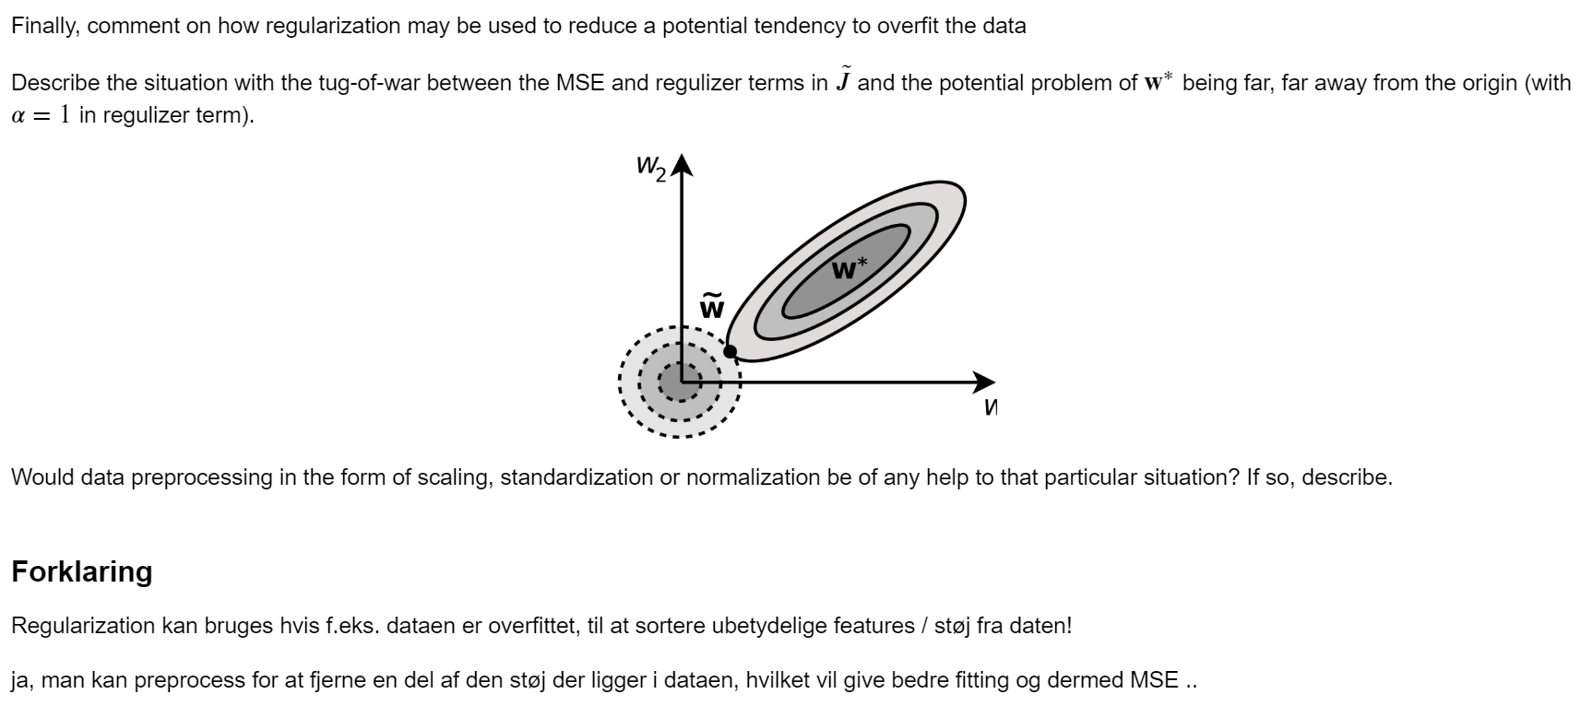

# Gridsearch

## Qa

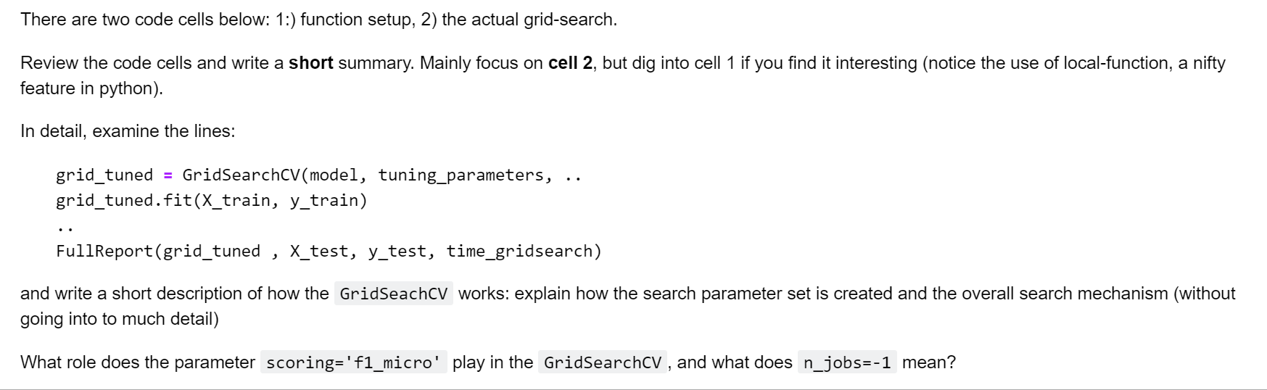

### Cell 1

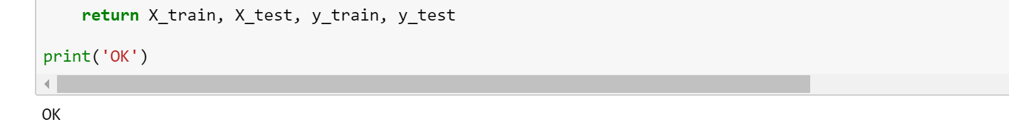

### Cell 2

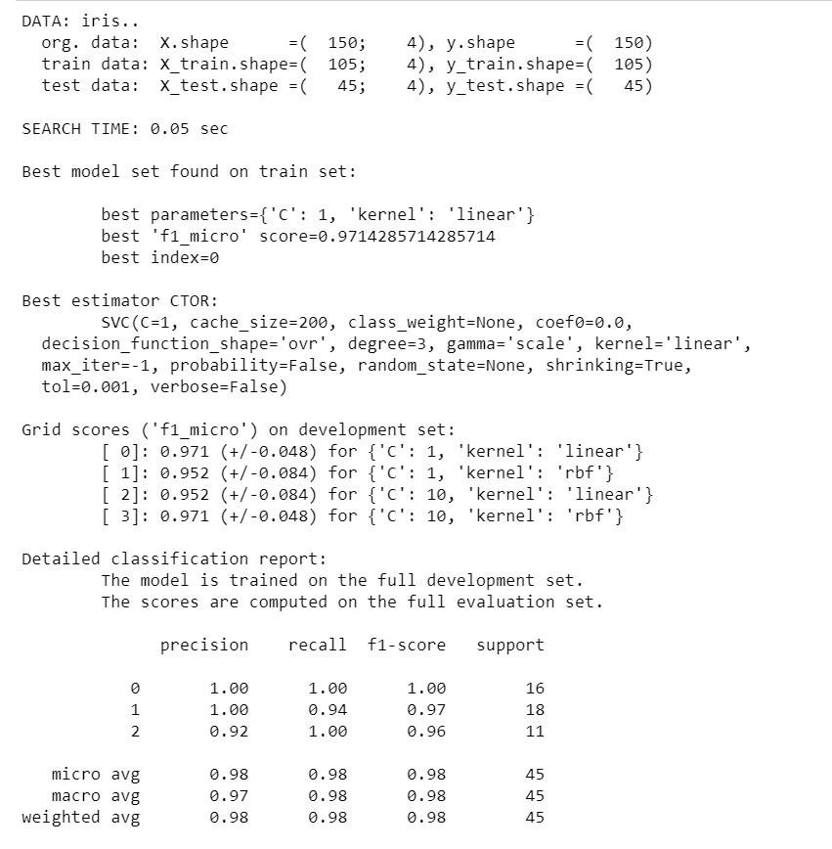

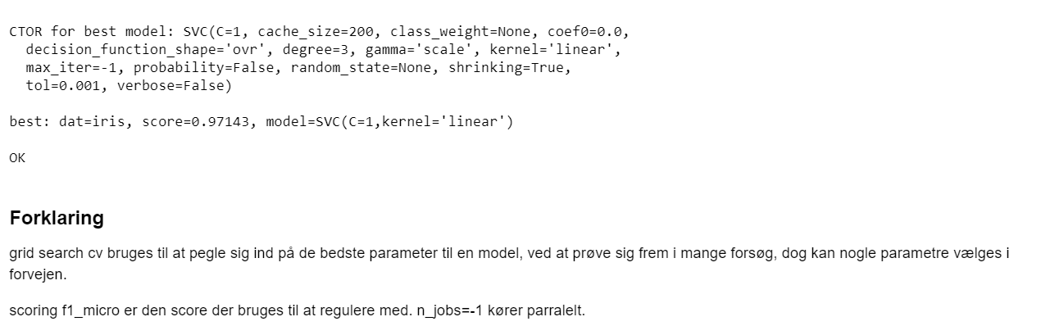

## Qb

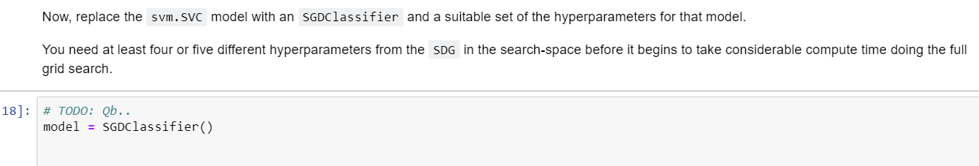

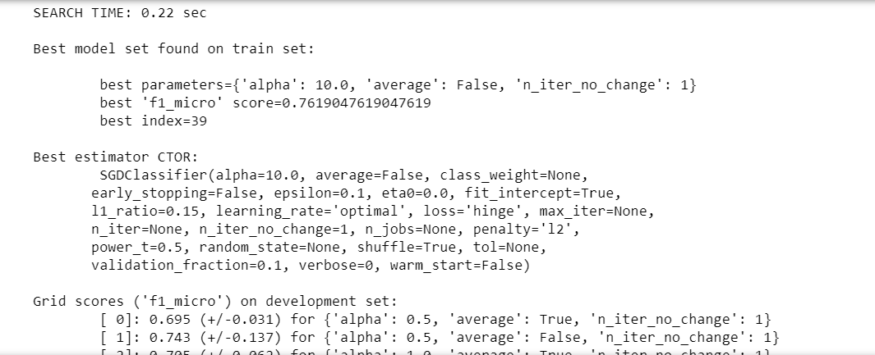

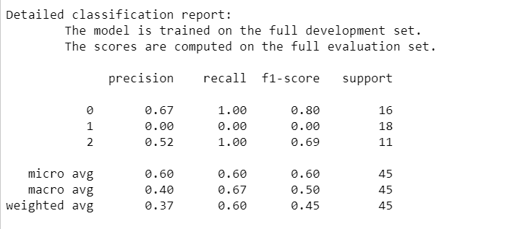

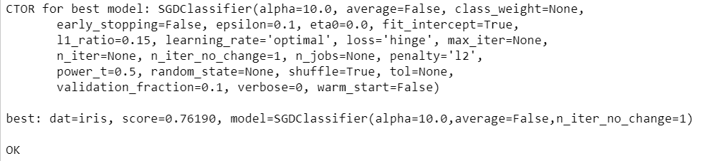

## Qc

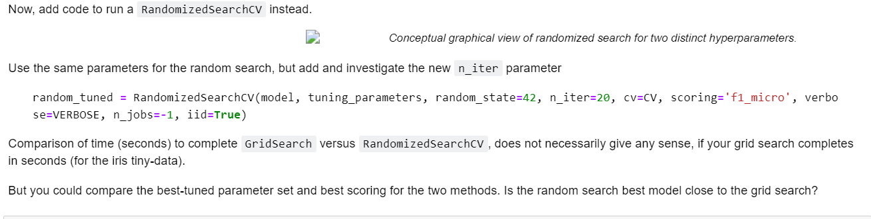

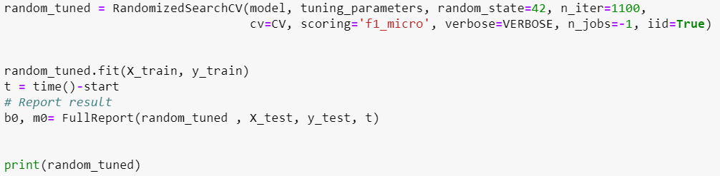

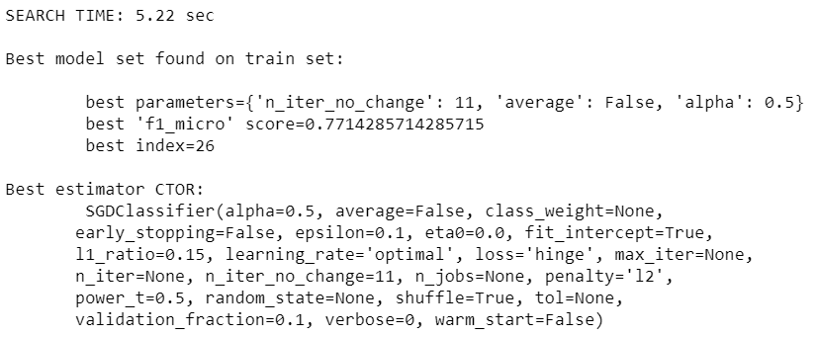

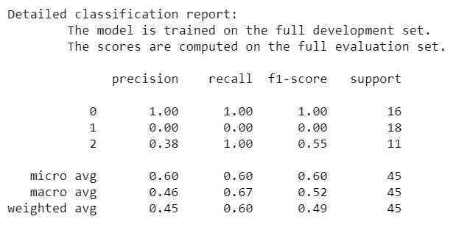

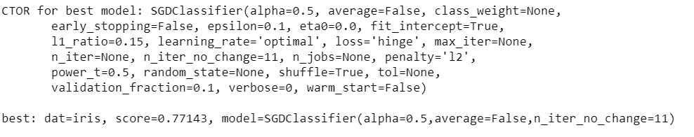

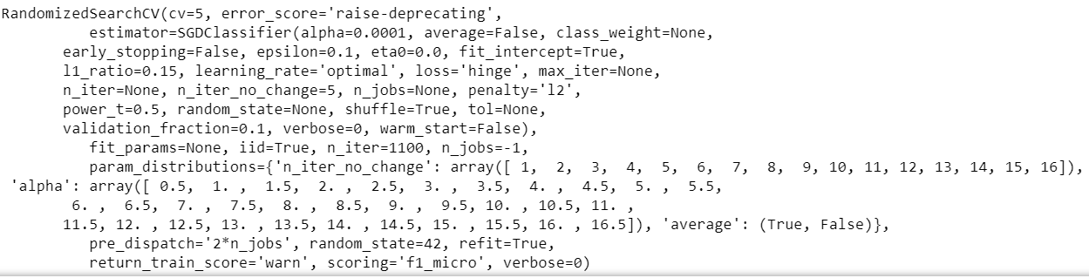

## Qd

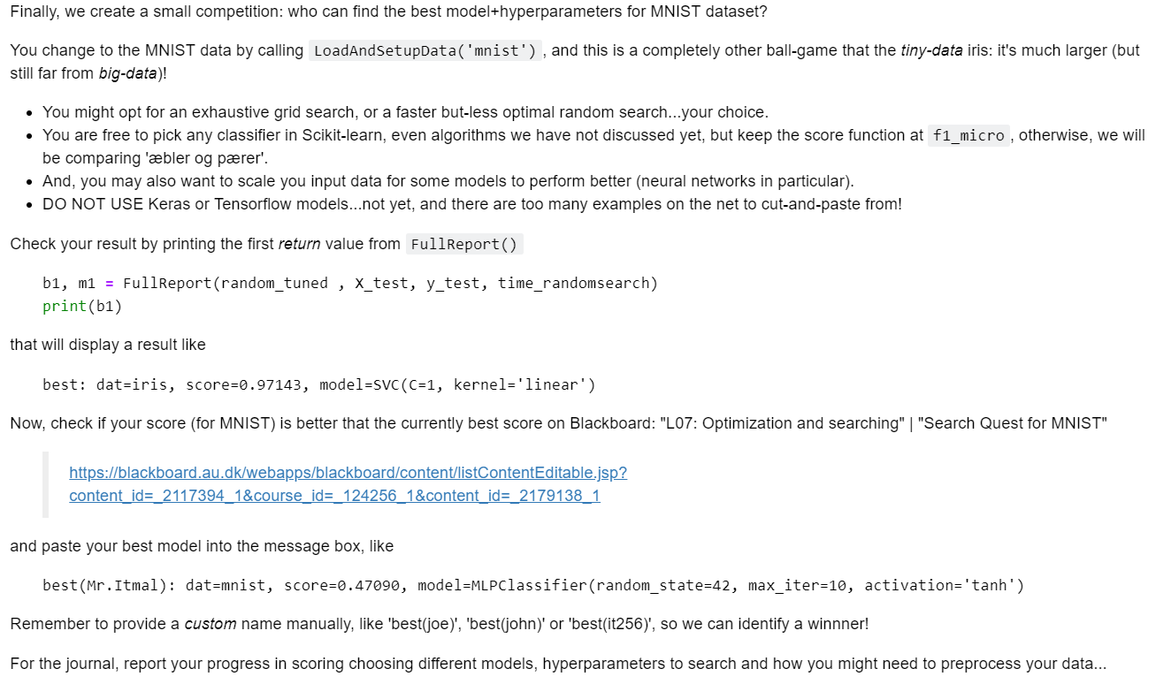

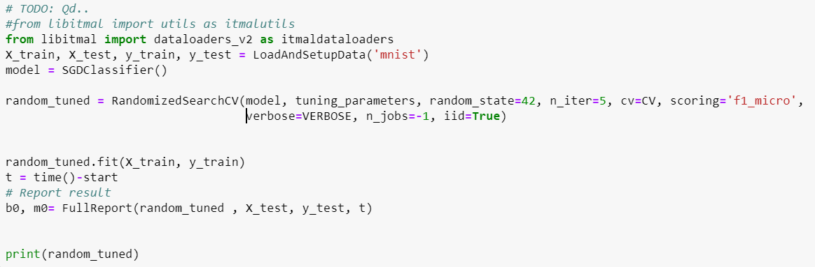

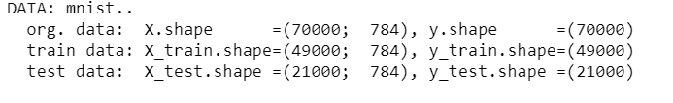

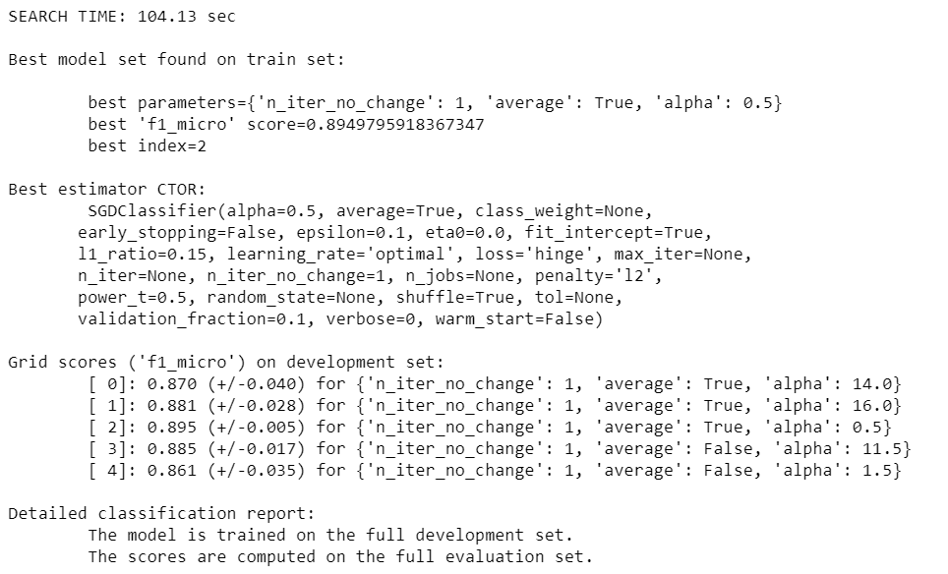

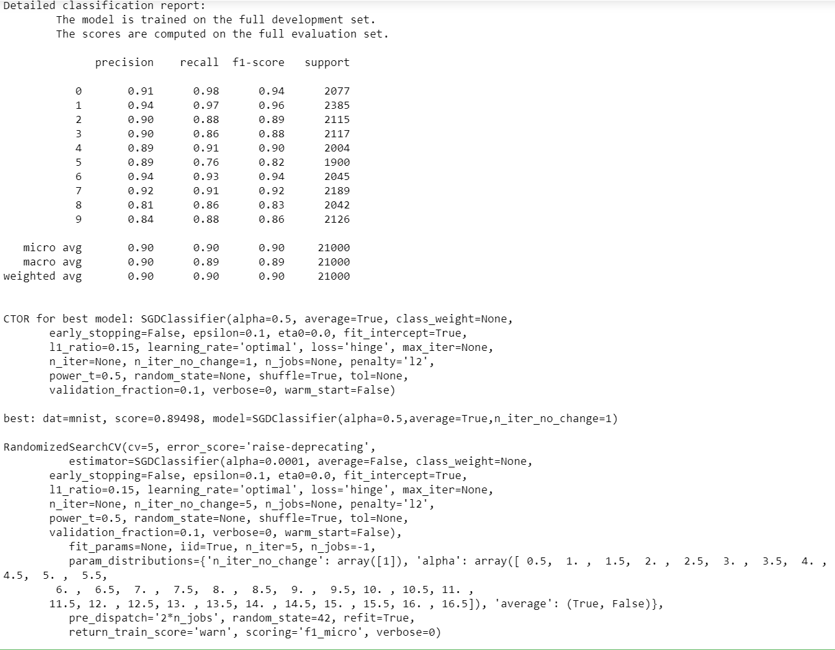

# Speed up by compression

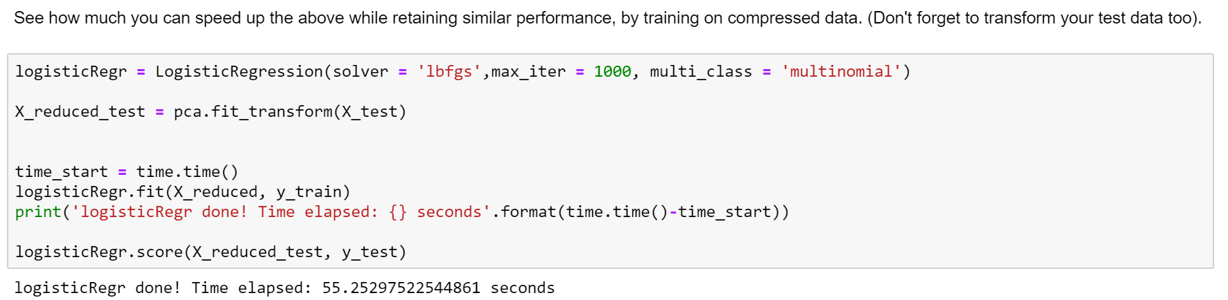

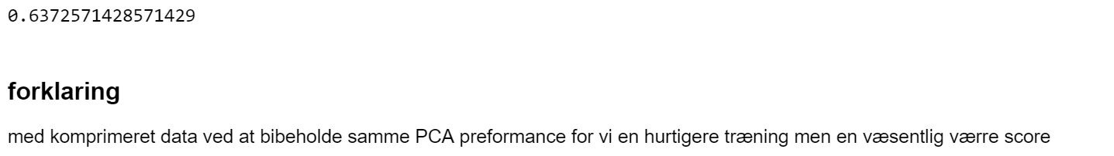

# Noise reduction

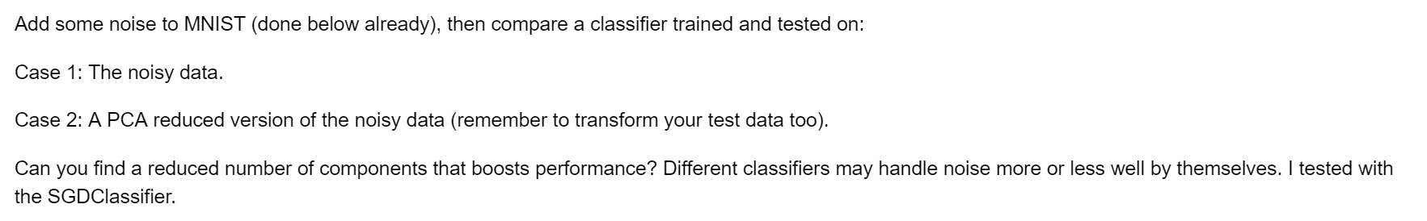

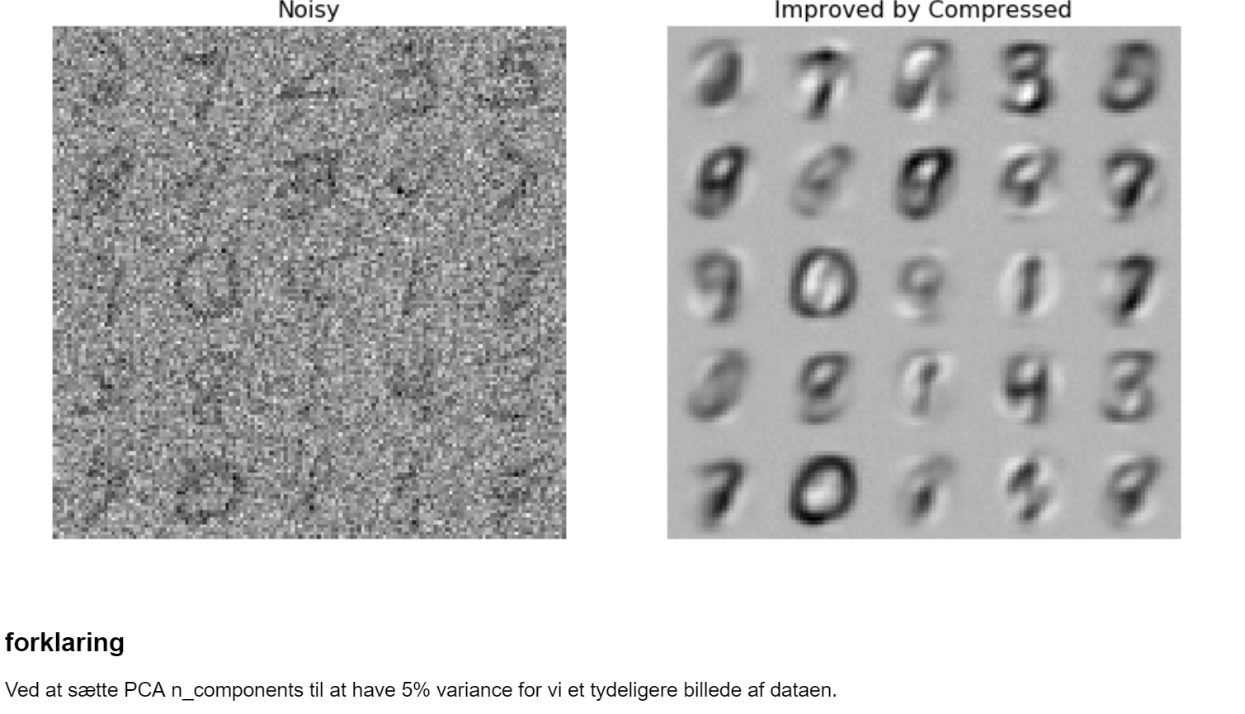

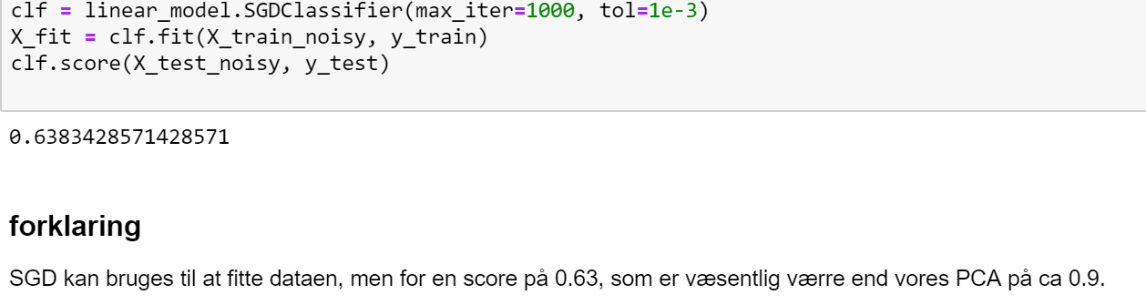

# PCA -> t-SNE features

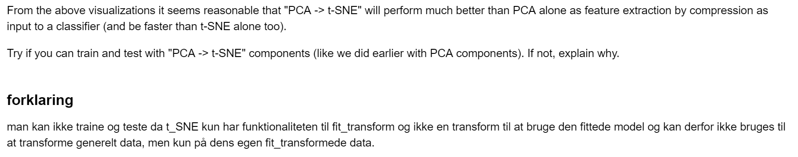

# Neurons

## Qa:





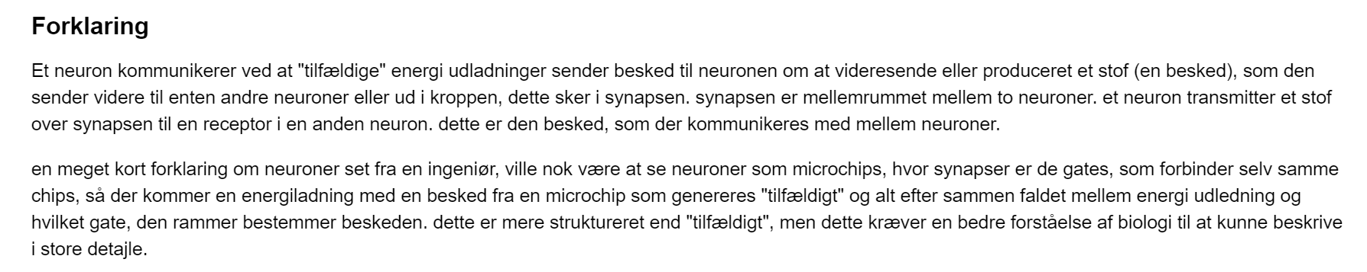

## Qb:



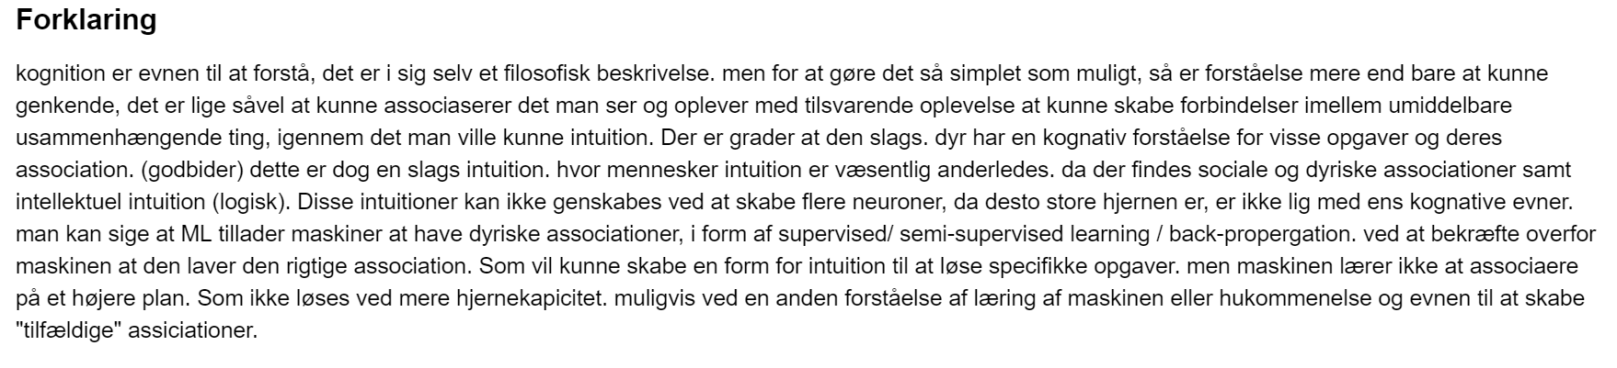

# Perceptron

## Qa:



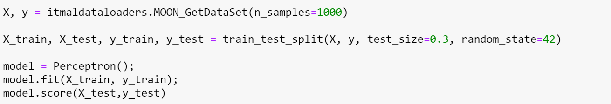

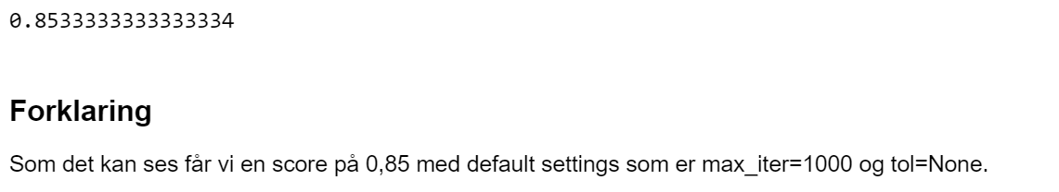

## Qb:



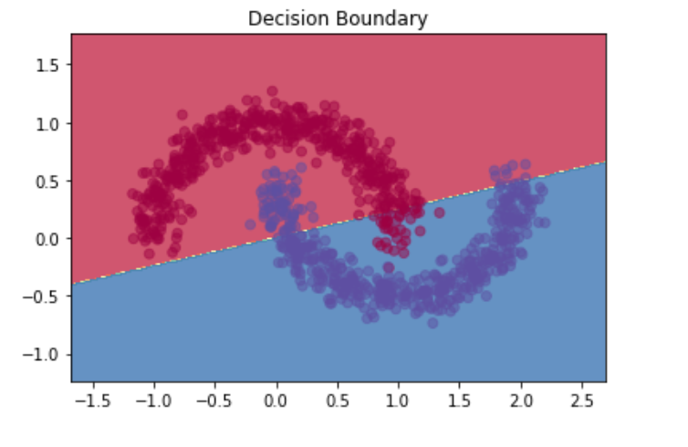

## Qc:

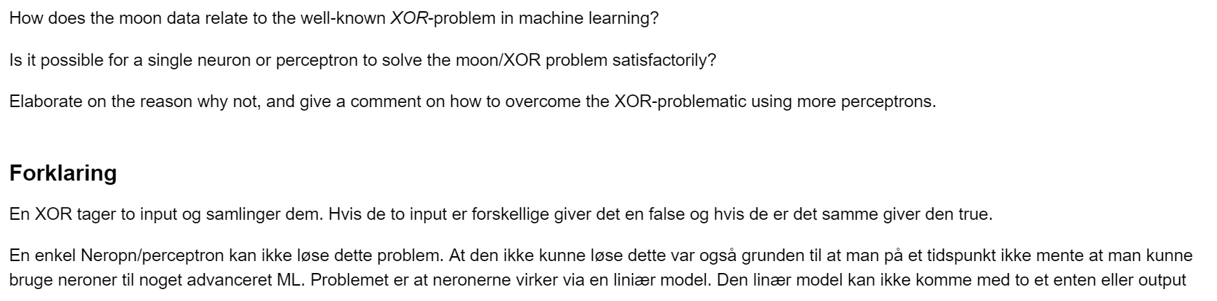

## Qd:

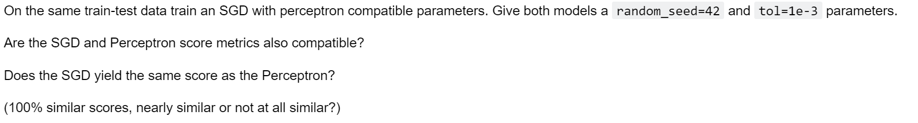

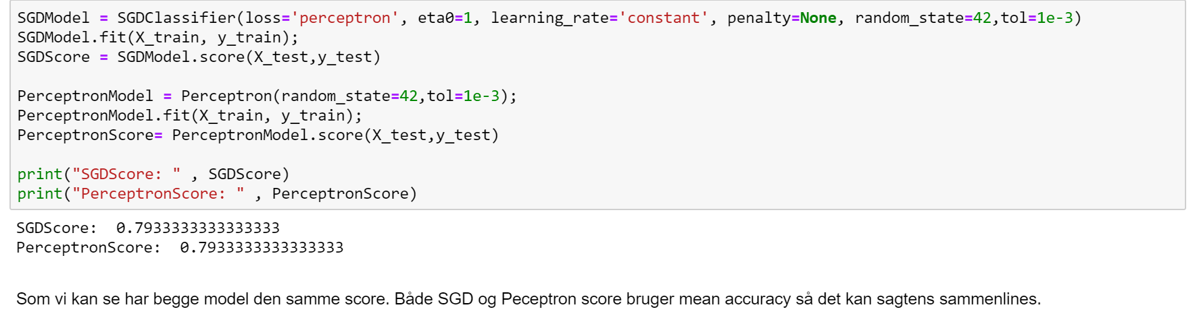

# Multi-layers Perceptrons (MLP)

## Qa:

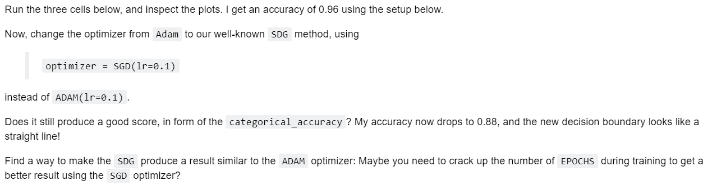

### Cell 1



### Cell 2

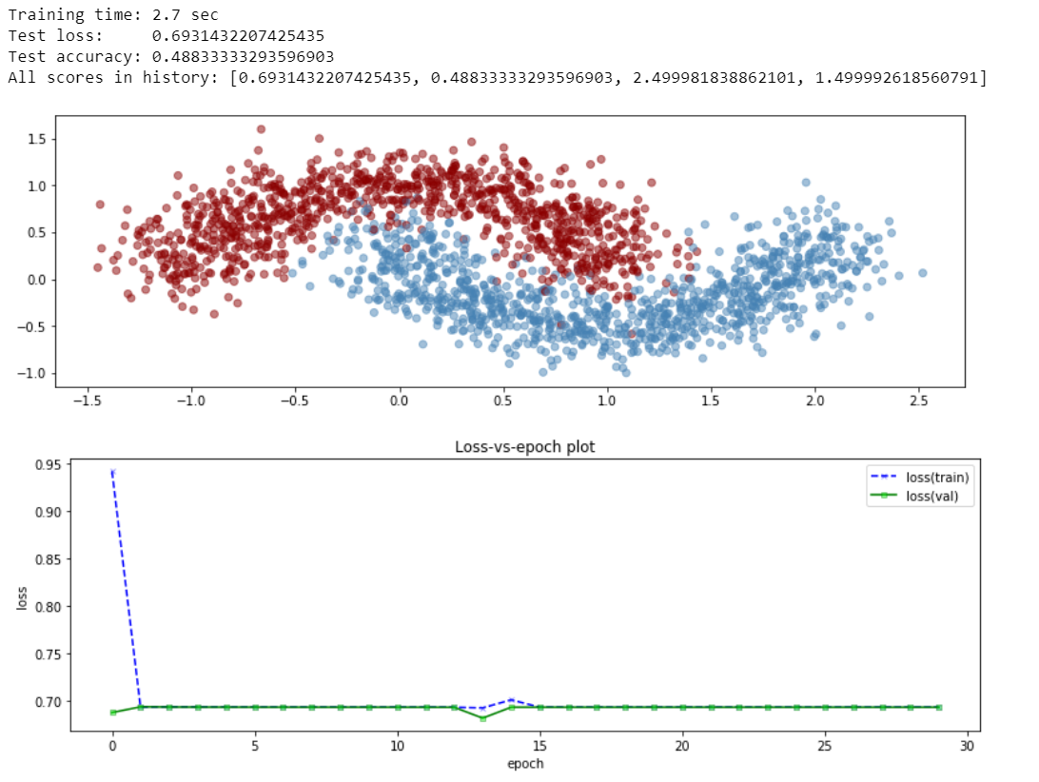

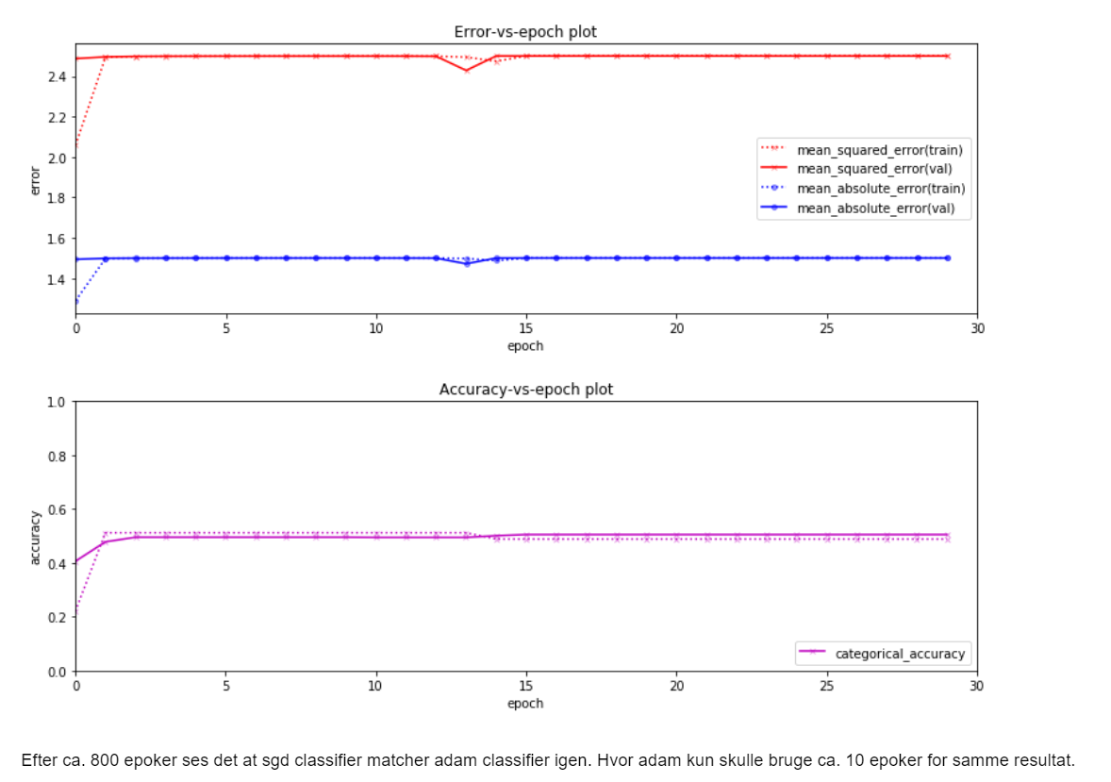

### Cell 3

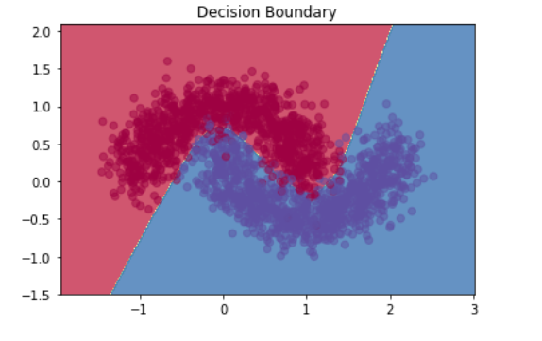

## Qb:

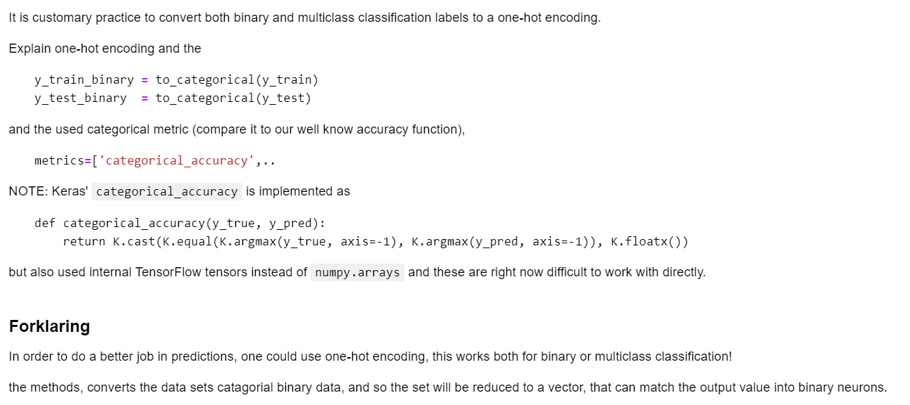

## Qc:

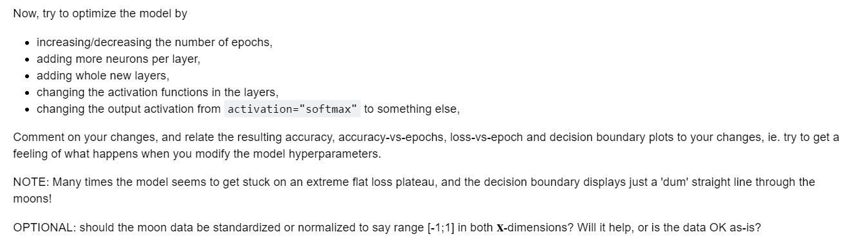

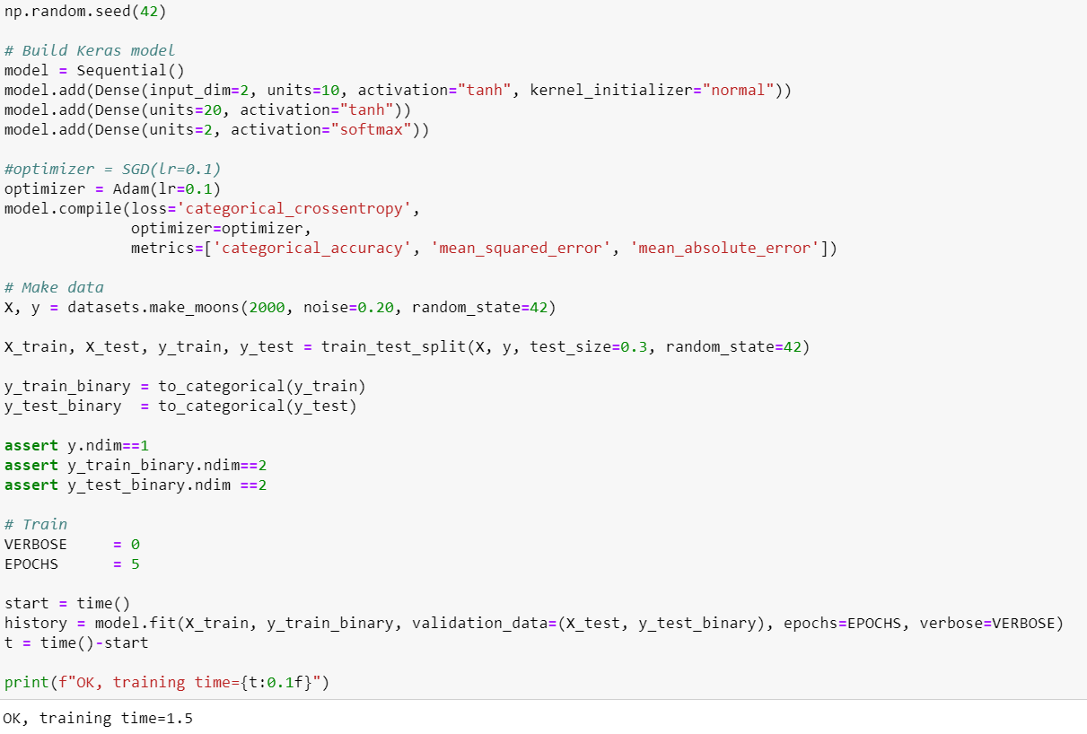

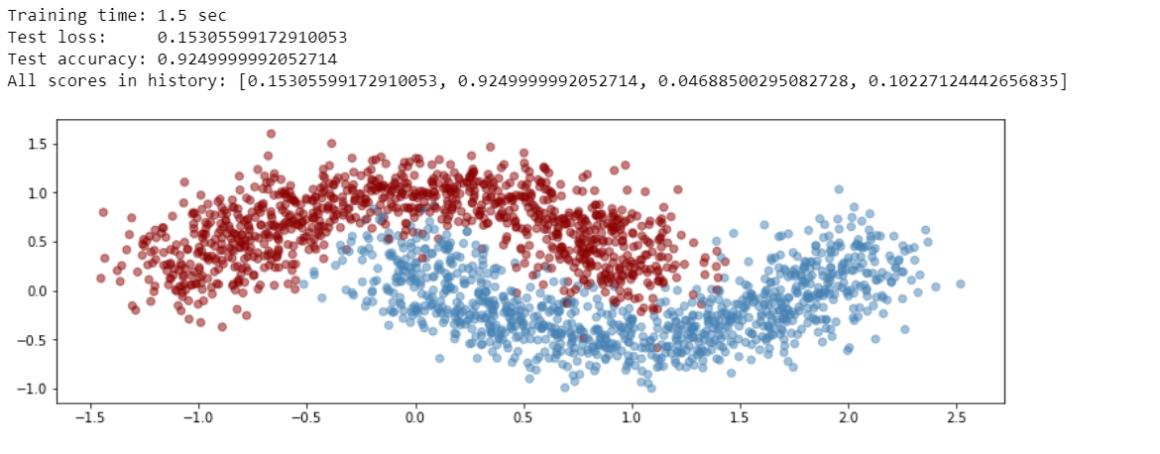

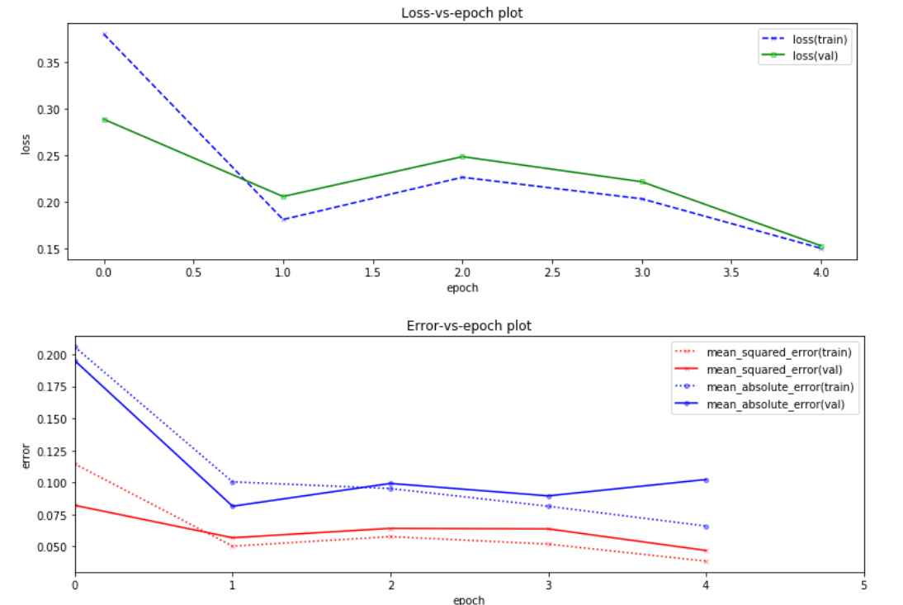

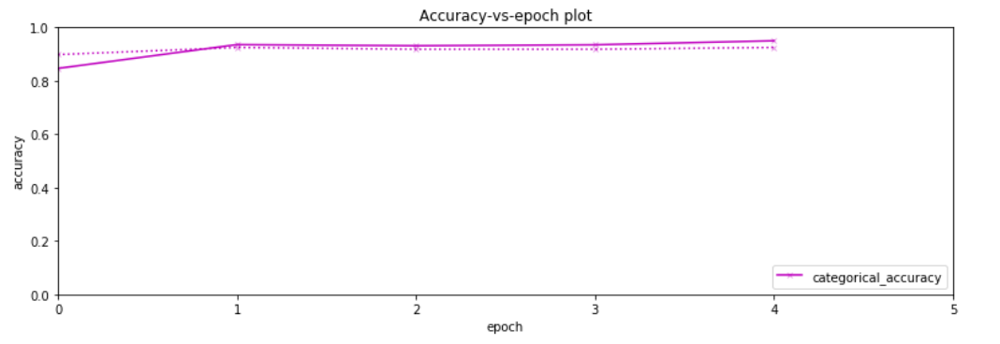



# Keras Multi-Layer Perceptrons (MLP’s) on MNIST-data

## Qa:



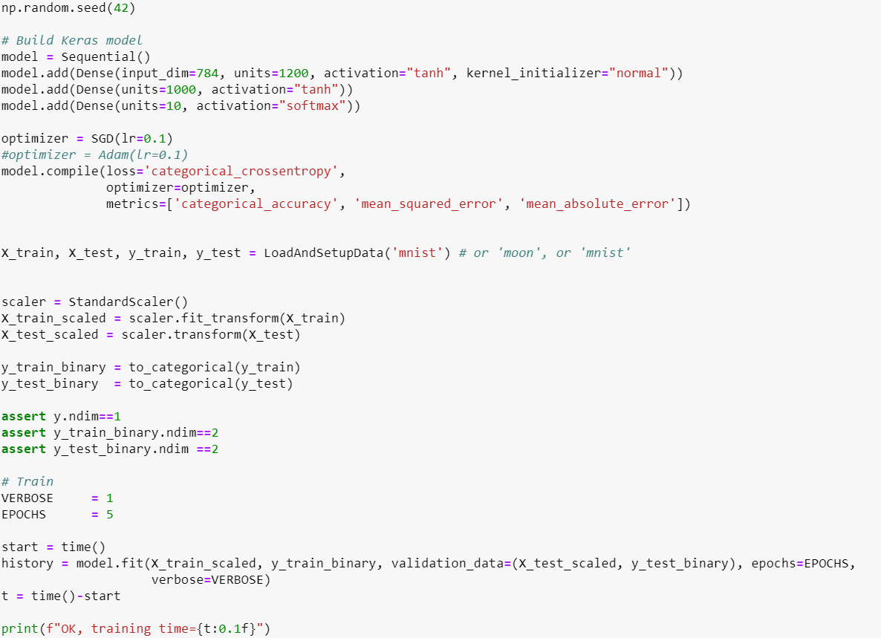

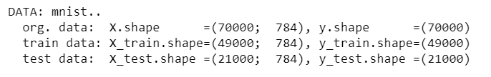

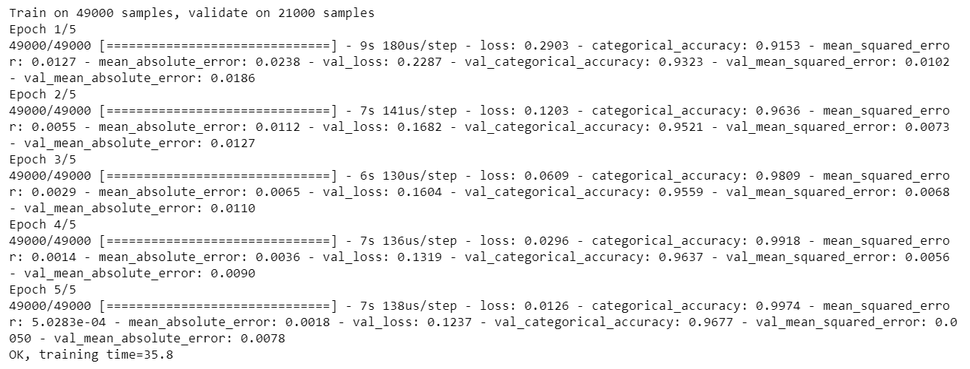

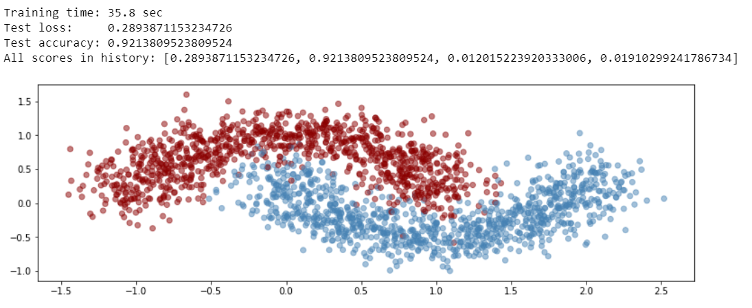

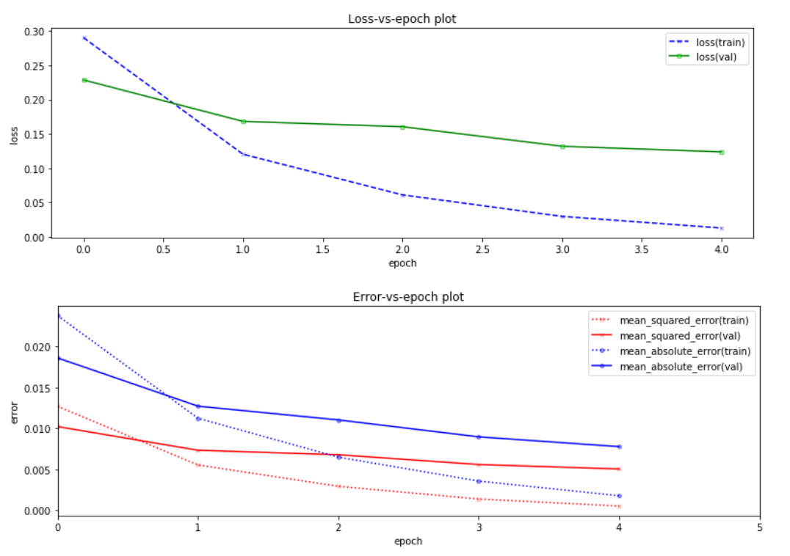

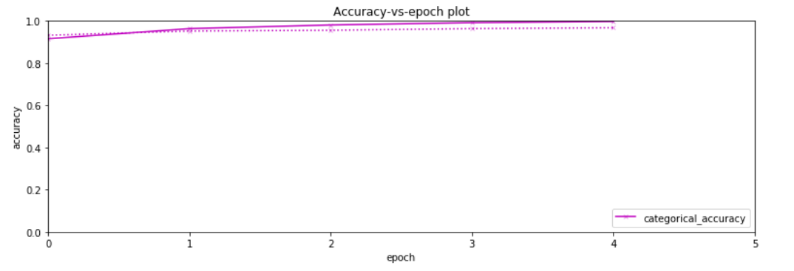

## Qb:

